Executing automated steps
In this section, you’ll learn how to create your first BPMN 2.0 process with the Camunda Modeler and how to execute automated steps. Start by opening up Camunda Modeler.

Create a new BPMN Diagram
Create a new BPMN diagram by clicking File > New File > BPMN Diagram.
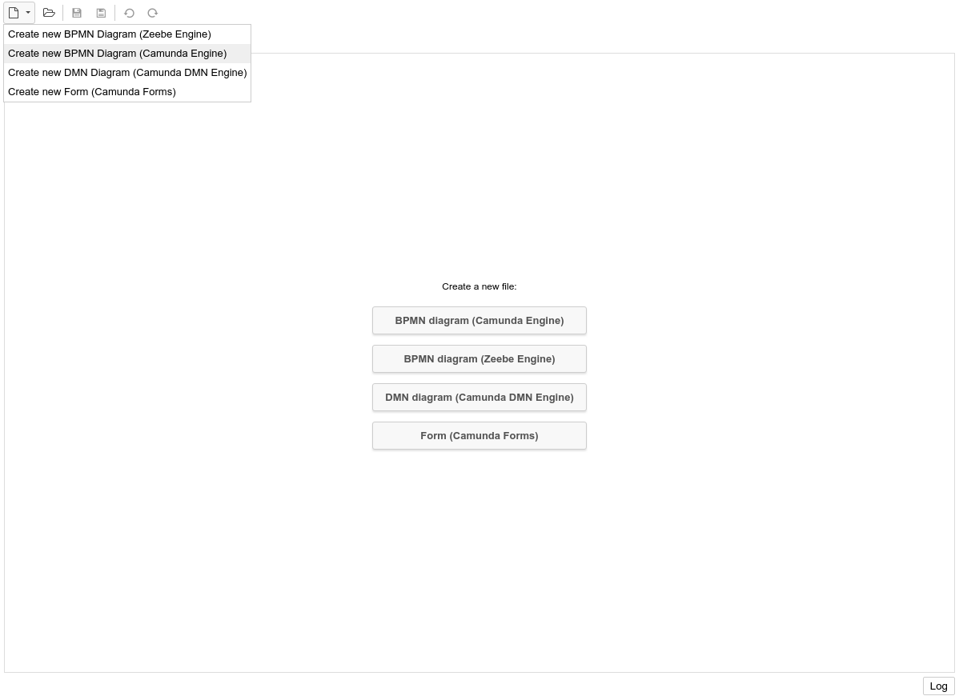

Start with a Simple Process
Start by modeling a simple process.
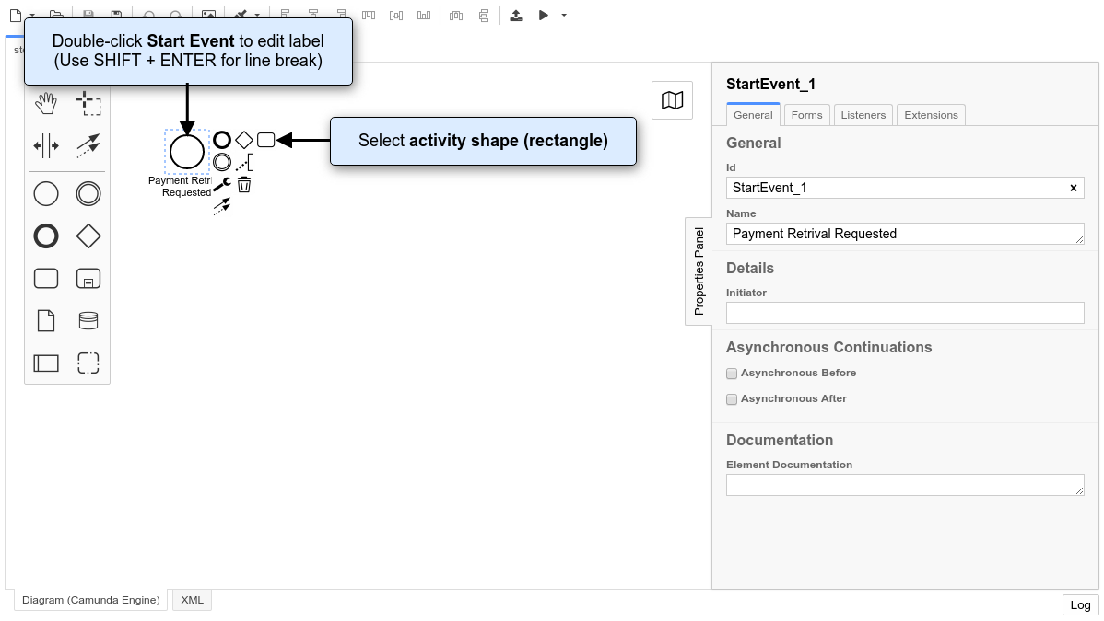
Double-click on the Start Event. A text box will open. Name the Start Event “Payment Retrieval Requested”.

Hint
When editing Labels, you can add line breaks using Shift + Enter.
Click on the start event. From its context menu, select the activity shape (rounded rectangle). It will be placed automatically on the canvas, and you can drag it to your preferred position. Name it Charge Credit Card. Change the activity type to Service Task by clicking on the activity shape and using the wrench button.
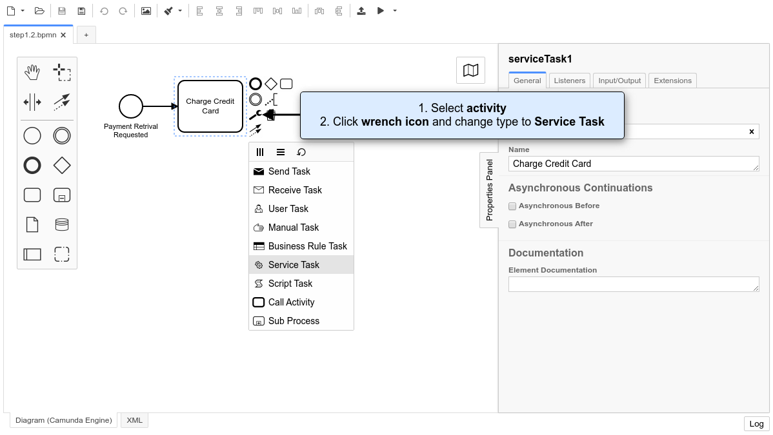
Add an End Event named Payment Received.
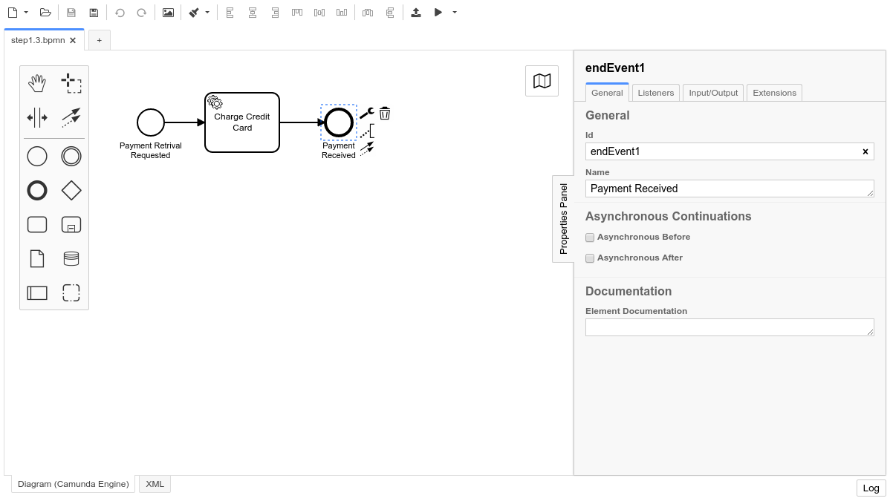

Configure the Service Task
There are different ways to execute service tasks using Camunda Platform. In this example, we’ll use the external task pattern. Open the Properties Panel within the Camunda Modeler and click on the Service Task you just created. Change the Implementation to External and use charge-card as the Topic.
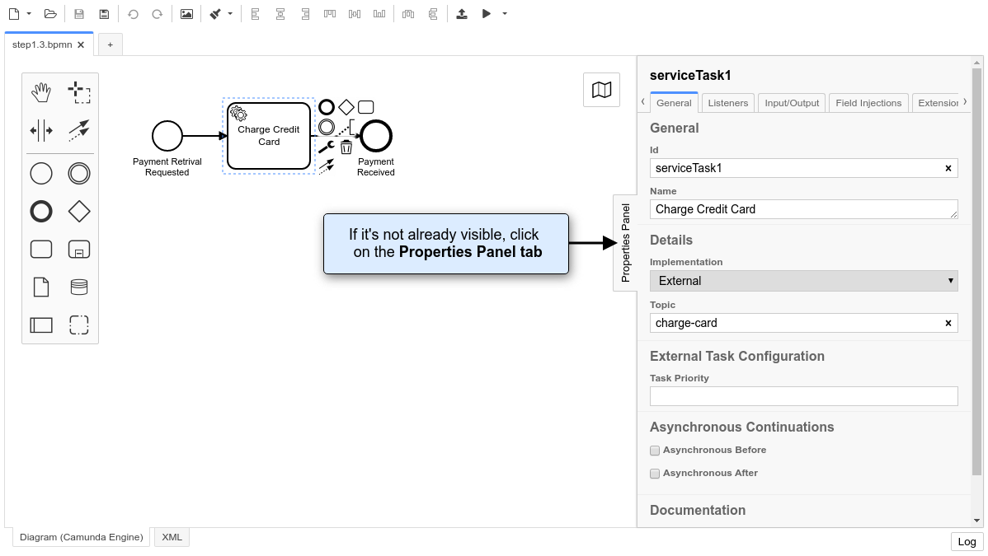

Configure Properties for Execution
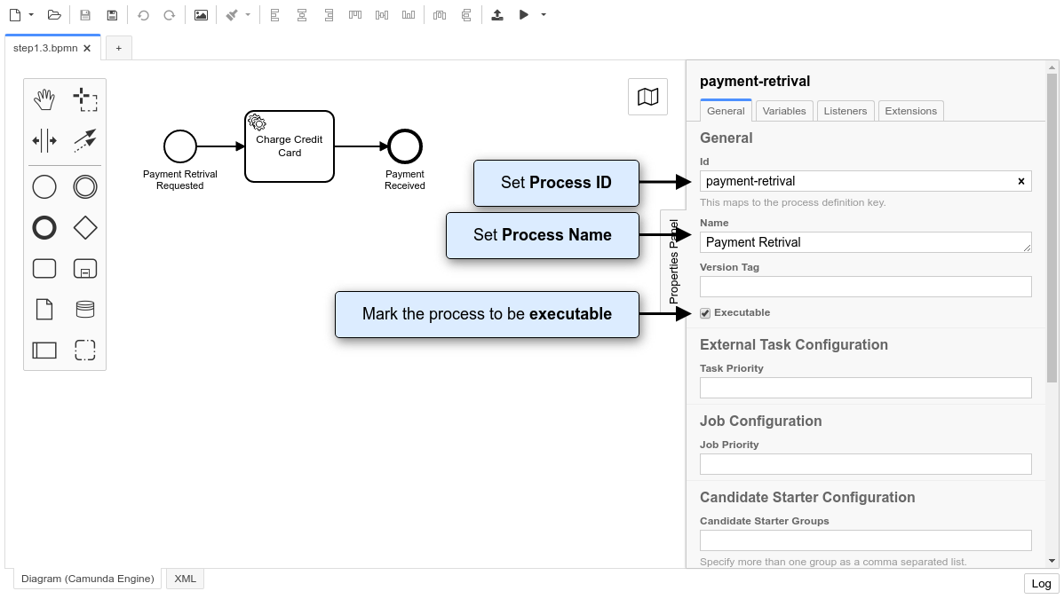
Because we’re modeling an executable process, we should give it an ID and set the isExecutable property to true. On the right-hand side of the canvas, you find the properties panel. When you click on empty space on the modeling canvas, the properties panel will display the properties of the process itself.
First, configure an ID for the process. Type payment-retrieval in the property field Id. The property ID is used by the process engine as an identifier for the executable process, and it’s best practice to set it to a human-readable name.
Second, configure the Name of the process. Type Payment Retrieval in the property field Name.
Finally, make sure the box next to the Executable property is checked. If you don’t check this box, the process definition is ignored by the process engine.

Save the BPMN Diagram
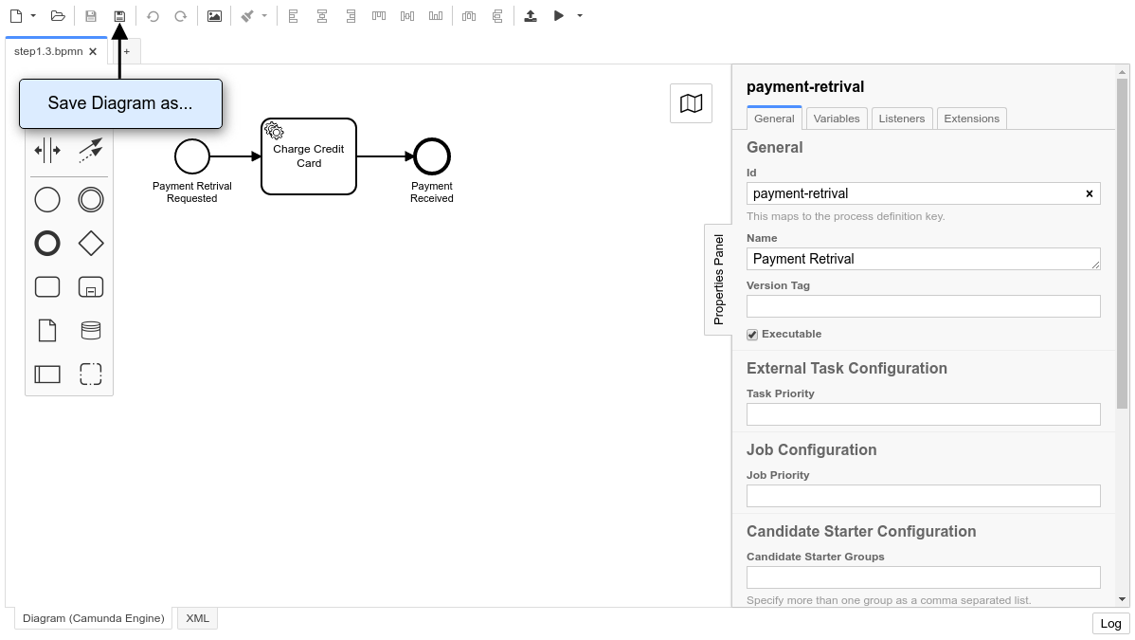
When you’re done, save your changes by clicking File > Save File As.. or by using the Save Button. In the dialogue that appears, navigate to a folder of your choice and save the diagram as something like payment.bpmn.

